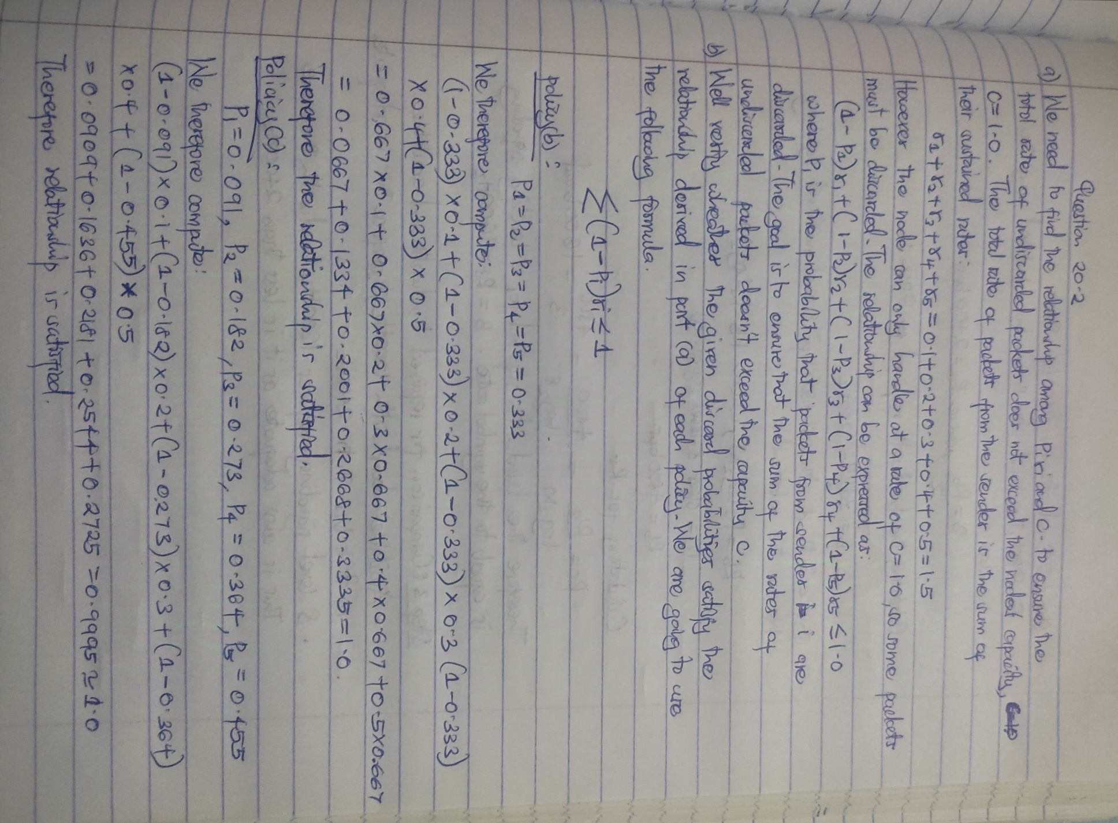

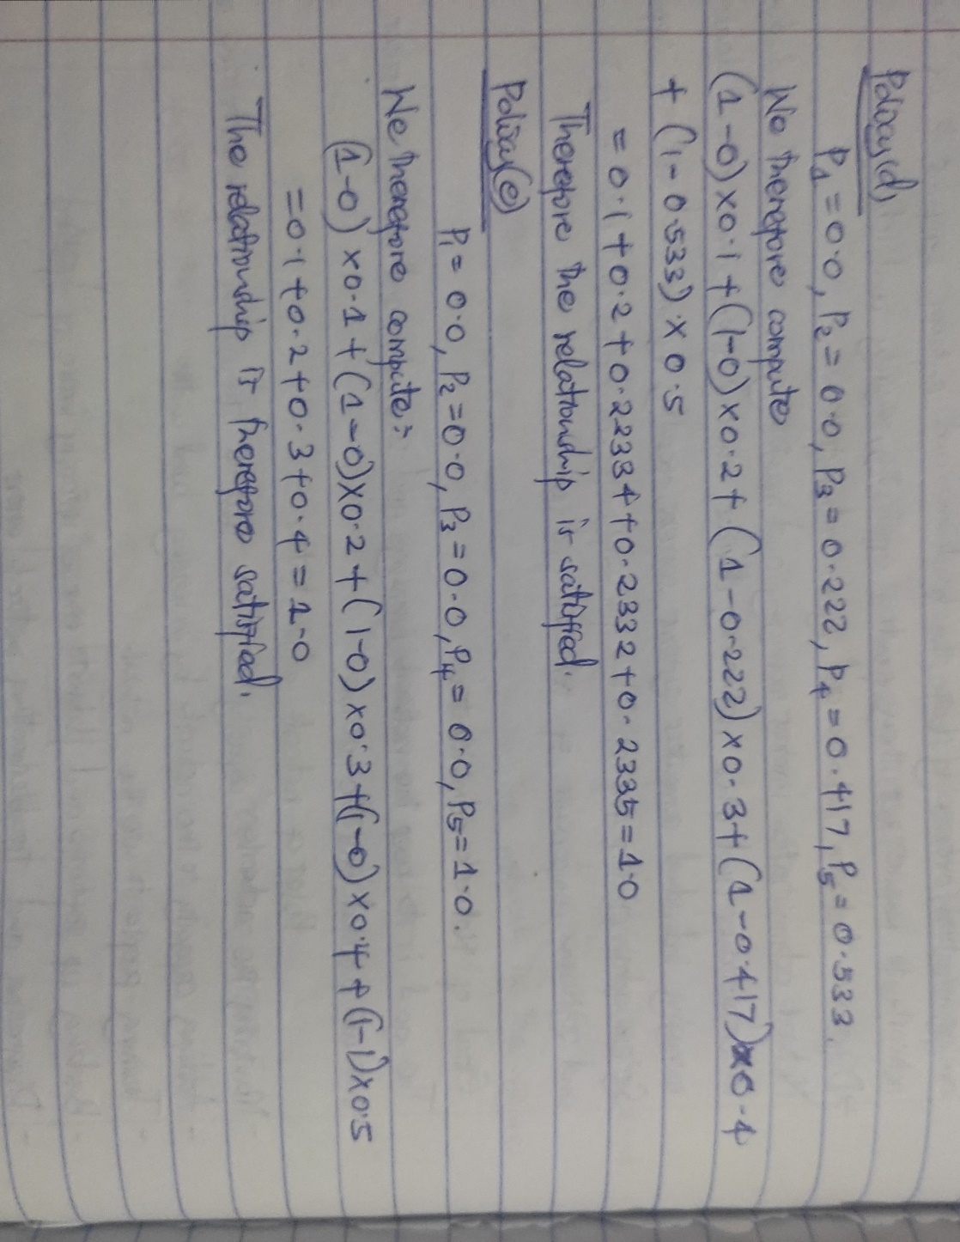



**Question 20.5: Advantages of the algorithm**

1. **Congestion Detection:**

* The algorithm is best suited to follow the number of frames in the queue in real time.Thus it can calculate the average load LLL to alarm the network is crowded and to respond before the consequential dull performance of the system.

**2. Proactive Congestion Avoidance:**

* Once the load crosses a particular level, the algorithm can raise congestion-avoidance signals like the setting of congestion notification bits, the forward explicit congestion notification (FECN) or backward explicit congestion notification (BECN) in Frame Relay. This way, further traffic is not overload on the system, which ensures the stability of the network continues to be achieved.

**3. Fair Resource Allocation:**

* The algorithm helps in managing network resources for instance bandwidth to make rational usage of them. So if there is congestion it is sensed early and the frame flow is controlled so as not to bind some users and deny services to others.

**4. Adaptability:**

* This algorithm is rather flexible in terms of arrival and departure events, and it can manage the size of a queue. This makes it easily flexible with the network traffic without so much efforts.

**5. Simple and Efficient:**

* Simple addition and averaging of the frame times are used by the algorithm to determine the load. Due to this simplicity, it is computationally bound to be efficient and feasible to run in real-time network systems without hogging system resources.

**6. Scalability:**

* In both small and large networks, the algorithm has been found to be efficient. If the frame handler maintains queue sizes, then the fundamental concepts of the algorithm are largely scalable with growing traffic and number of connections, it is thus flexible for large traffic networks.



